Installing Python
Got to pythin.org, download the latest version and install python. When installing ensure you tick the add to path.
Installing VScode Visual studio Code
Download visual studio code and install.
Open the VScode
Got to https://marketplace.visualstudio.com/items?itemName=ms-python.python
Extension Installation Details https://code.visualstudio.com/docs/python/python-tutorial#_prerequisites

Click install the extensions for python
Linter installation➔
From the VSCode ➔Press Ctrl+shft+p
Type Python: Select Linter and select pylint and install pylint when promptedt
Interpreter installation➔
From the VSCode ➔Press Ctrl+shft+p
Type Python: Select interpreter and select c:\Program files (x86)\Python 37 3\Python.exe
format installation➔
From the VSCode ➔Press Ctrl+shft+p
Type Format and select format document and install autopep8 when prompted
autoPep8 is a style guide
Press Ctrl+shft+p and select format document and all the text (x=1) is now formatted as (x = 1)
i.e
x =1
y =2
unit_price =3
Press Ctrl+shft+p select format document (formats automatically)
x = 1
y = 2
unit_price = 3

How to set format document automatically when saved:
Got to File➔Preferences➔Settings
Search for FormatonSave
Select Editor: Format On Save as shown in the picture 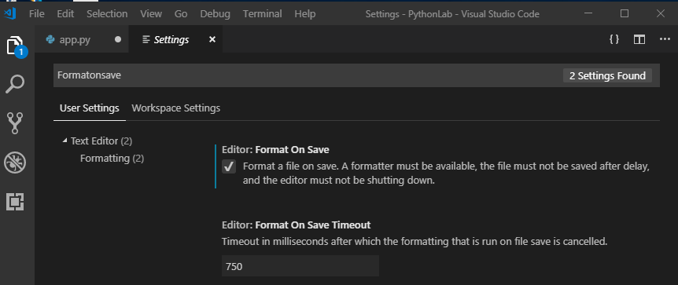

Installing Code Runner:
Open the square box  or ctrl+shft+ X
Search Code Runner 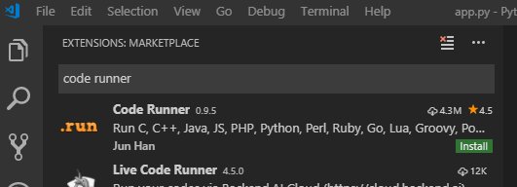
Click install to install the code runner and click reload if needed.
CTRL+alt+n to run the program in the terminal window
Change to python 3
(For windows this is fine but for mac also windows if needed)
Go to File➔Preferences➔Settings
Click the {} for windows (Open Settings JSON) 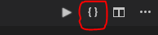 or … on mac
Search for Code-Runner.executorMap which list all the code runner on the left pane which is not editable
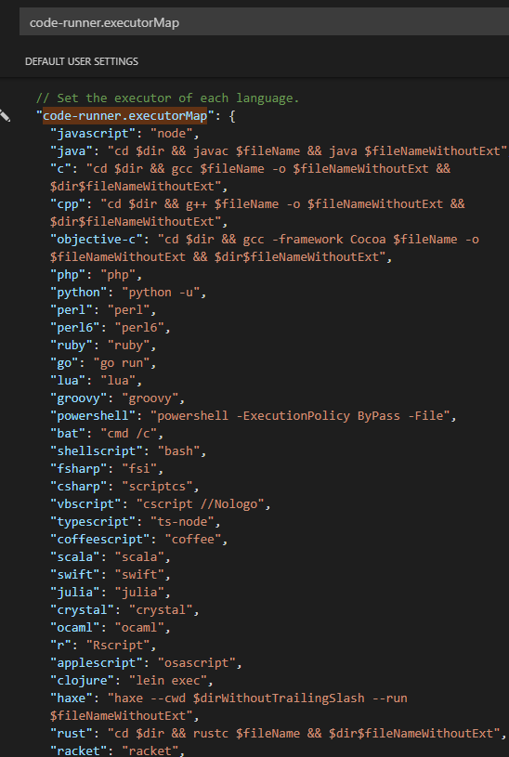
This is a default setting
Got to the right paneafter the last setting
Type “code-runner.executorMap” and press enter which will automatically copy all the code-runner.executorMap to the right side( User setting)
Before running code-runnerexecutorMap 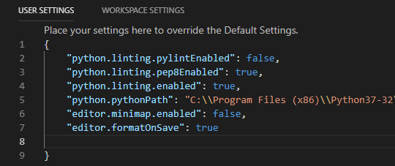
After running code-runner.executorMap 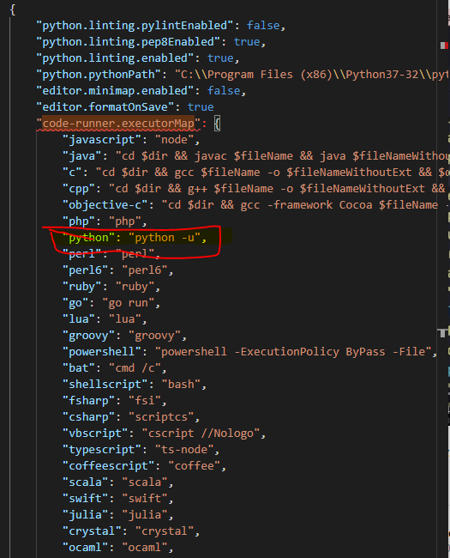

Now change Python: Python -U to Python3 as shown 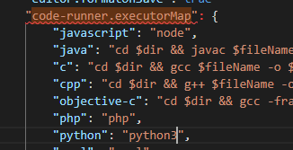
Save and exit

